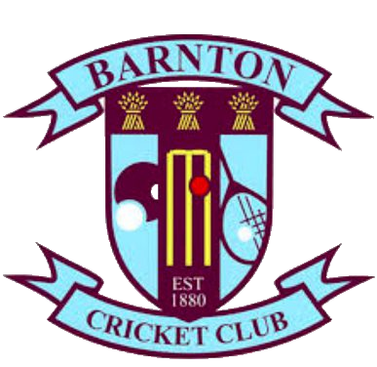

Starters

Soup of the day served with slices of ciabatta[GF] £4.25
Breaded garlic mushrooms served with salad and garlic mayonnaise [V] £5.25
Pate topped with Chutney served with toasted ciabatta slices £5.60
Prawn cocktail served on a bed of lettuce, a slice of lemon and brown bread [GF] £6.25
Bruschetta - toasted ciabatta topped with goats cheese, tomato, red onion drizzled with balsamic glaze £5.95

Mains
Topside of beef served with handmade Yorkshire pudding [GF] £11.95
Roast turkey served with Sage and onion stuffing [GF] £10.95
Walnut and Cashew nut roast [V] [GF] £11.50
All of our roasts are served with mash potato, selection of vegetables and handmade roasties
Hand battered fish and chips, served with tartare sauce choice of mushy or garden peas [GF] £10.95
Pie of the day served with either mash potatoes or hand cut chips and garden peas [v] options available £10.95
6oz Cheese and bacon burger topped with onion rings served on a brioche bun with skin on fries and coleslaw £10.95
Chicken burger seasoned with Cajun spices topped with melted cheese, served on a brioche bun with skin on fries and coleslaw £9.95
Creamy broccoli pasta bake served with garlic ciabatta [v] £9.95.

Sides
Onion rings £2.00
Hand cut chips £3.00.
Garlic ciabatta £3.95
Skin on fries £2.50
Side salad £3.50

Childrens menu £5.95
Hand battered chicken goujons chips served with beans or peas [GF]
Hand battered fish goujons chips served with beans or peas [GF]
Sausage and mash
Pasta Bolognese
Sunday Roast [GF]

Desserts £5.95
Waffle served with vanilla ice cream and chocolate sauce.
Cheesecake of the day served with vanilla ice cream
Handmade apple crumble served with custard.
Belgian chocolate torte served with vanilla ice cream. [GF]
Vanilla ice cream sundae with choice of raspberry or chocolate sauce and a choice of topping (Smartie, Flake, Oreo) [GF]
Cookie dough served with vanilla ice cream
Function room and buffet options available, please enquire at the bar.

